Jack Johnson

August 30, 2021

Section End Project: Task Planner

Link to my GitHub repository: <https://github.com/jjohn98/2058519_Jack_Johnson_Mean_Stack>

This project is located in ~/Phase3/Task Planner.

In this project, I created 3 files. The first file, taskLog.json, just holds the tasks in json format for storage. The second file, taskPlanner.js contains all of the express js code written to complete the webpages and their functionality. The third file, taskPlannerHome.html, is the html file for the home page which has the forms in it.

Inside of taskPlanner.js, there are multiple get and post methods for each of the “webpages” in which the functionality lies. The original page is taken from taskPlannerHome.html, and then from there each of the other simple pages are just held within the get and post methods. Each of these methods are capable of reading from and writing to the taskLog.json file. The user can add new tasks, which will create the json object and add it to the array as long as a task with the same task id does not exist already inside of the file. The user can delete a task simply by giving the task’s id. And finally, the user can display all of the tasks in a table format with the link at the bottom to the “List All Tasks” page.

The files for this project will be in the GitHub repository, as well as the source code section of the submission on Simplilearn.

Screenshots of Webpages:

Home Page:

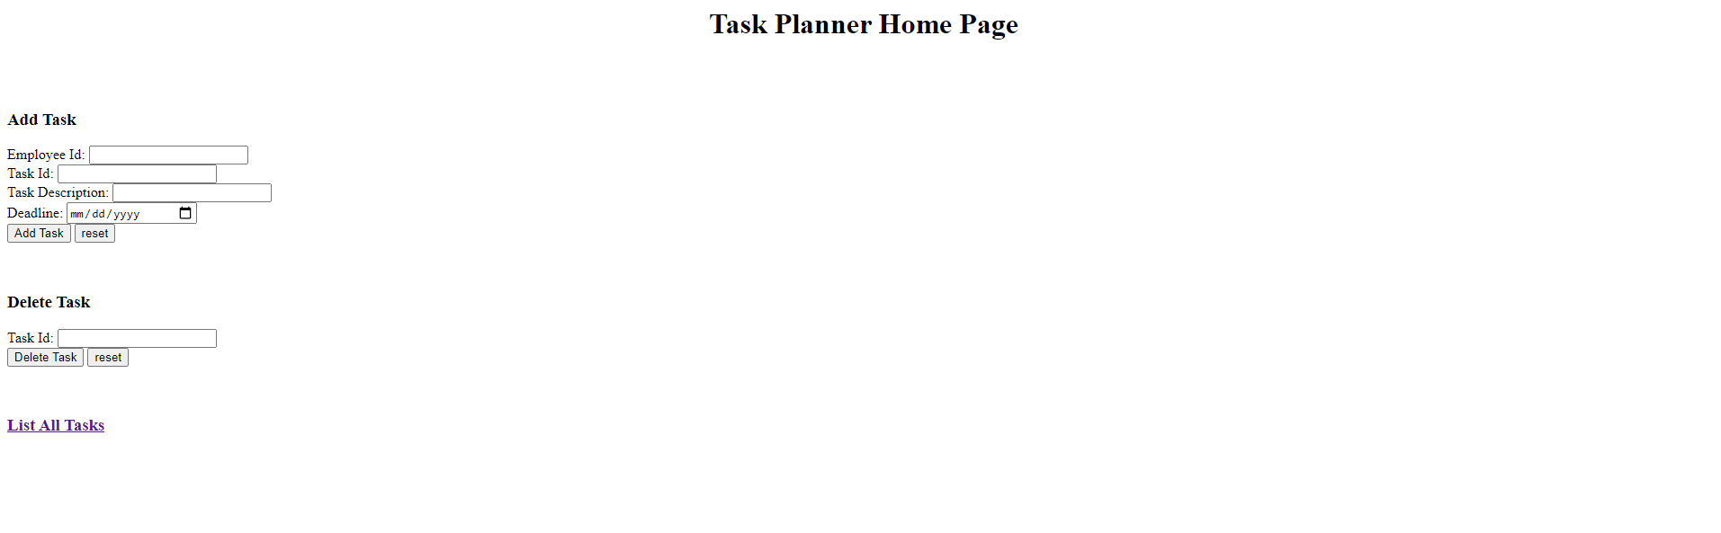

Home Page filled add task form:

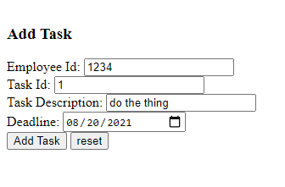

Successful new task:

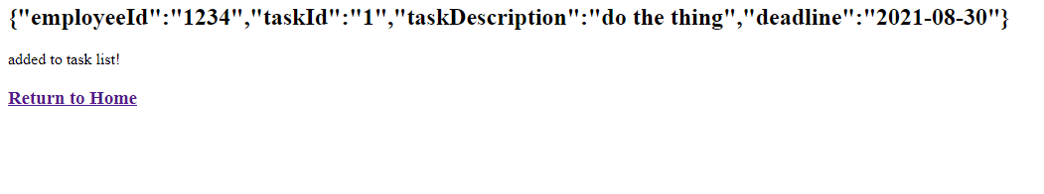

Failed new task:

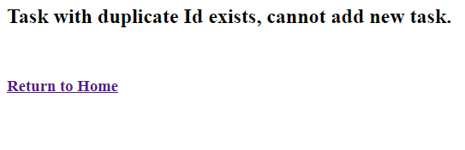

Delete Task form:

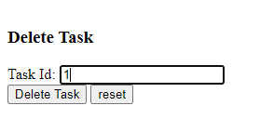

Successful delete:

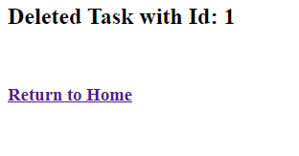

Failed delete:

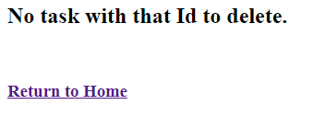

List all tasks page:

